Murlan Multiplayer

Technical Design Document

Angular – Spring Boot communication API

Angular StompClient -> Connect

* /game

Angular StompClient -> Subscribe

* /topic/lobby
  + LobbyEvent
    - LobbyEventType
      * ROOM_OPENED
      * ROOM_UPDATED
      * ROOM_CLOSED
      * USER_JOINED
      * USER_LEFT
* /user/queue/lobby
  + LobbyMessage
    - LobbyMessageType
      * LOBBY_STATE
      * CREATE_ROOM_SUCCESS
      * CREATE_ROOM_FAILURE
      * JOIN_ROOM_SUCCESS
      * JOIN_ROOM_FAILURE
* /topic/room/{roomId}
  + RoomEvent
    - RoomEventType
      * PLAYER_JOINED
      * PLAYER_DISCONNECTED
      * PLAYER_LEFT
      * PLAYER_PLAYED
      * ROUND_STARTED
      * ROUND_ENDED
      * GAME_ENDED
* /user/queue/room/{roomId}
  + RoomMessage
    - RoomMessageType
      * ROOM_STATE
      * INVALID_PLAY
      * YOUR_TURN_TO_PLAY
      * YOUR_TURN_WAS_SKIPPED
      * YOU_WON_ROUND
      * YOU_LOST_ROUND

Angular StompClient -> Publish

* /app/lobby/command/createRoom – CreateRoomController.java
* /app/lobby/command/joinRoom – JoinRoomController.java
* /app/room/command/leaveRoom – LeaveRoomController.java
* /app/room/command/makePlay – MakePlayController.java

Functional requirements

* User is given the choice of playing as a guest.
* User visits the Lobby page and sees real time updates happening without his interaction.
* User is shown the option to create a new game room.
* User can select and join an available game room.
* After successfully joining, User is redirected to the Room page.
* Game automatically starts after the max number of players have joined.
* User's screen is updated in real time according to the game in play.
* On user's turn, user is asked to make his play.
* In case of connectivity issues, User should be informed accordingly.
* In case of connectivity issues, User should be able to re-join and play again, although the game may have continued in his absence.

Non-functional requirements

* Messages are exchanged with low latency.
* The order and time of messages sent to client are validated.
* Network error handling is consistent.
* Servers communicate with clients in real time and in an efficient way
* Software is designed to support horizontal scaling.
* Software is designed to support various types of game implementations in the future.
* System components can be easily added/removed based on the goals and requirements of the moment.

High-level overview

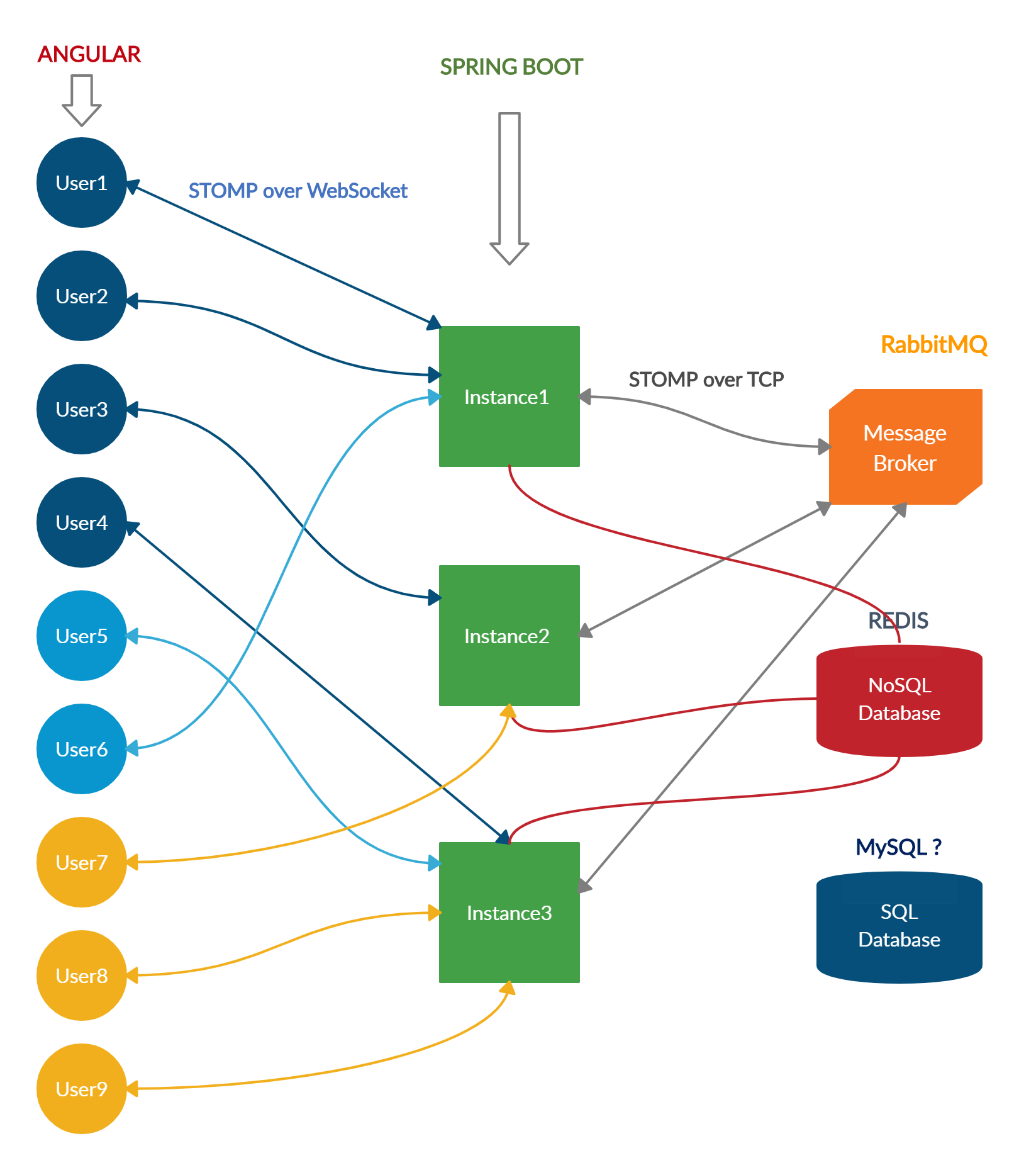

Simple use case – creating a new room

Precondition: Users have already connected and subscribed to /topic/lobby successfully.

